Kevin Bruce

Normalization #2

11/20/2014

1.

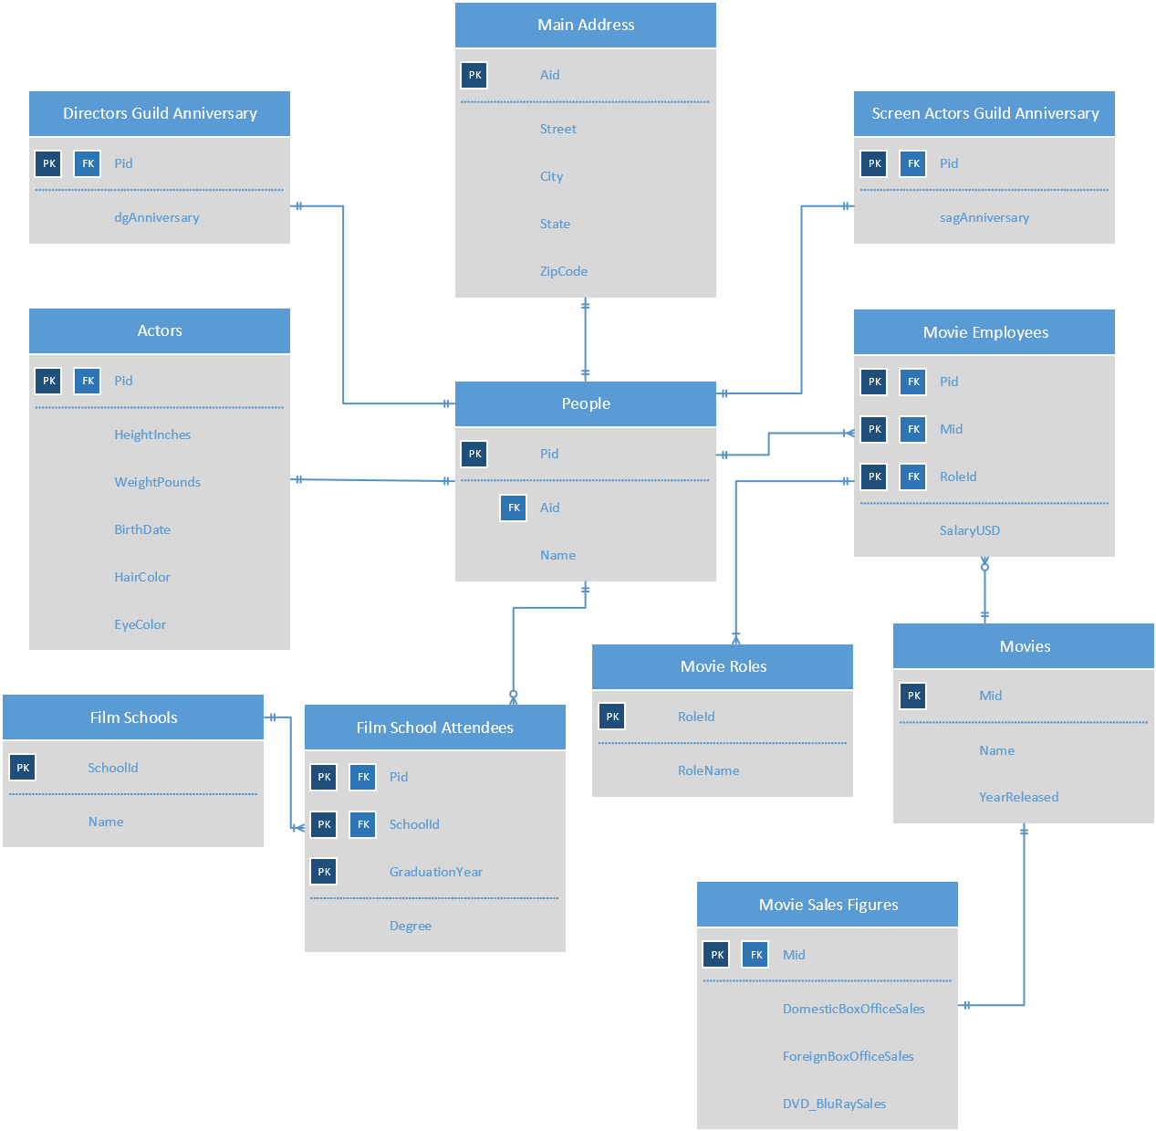

2. --People --

DROP TABLE IF EXISTS people; CREATE TABLE people (

pid char(4) not null,

aid char(4) not null references mainAddress(aid), name varchar(48), primary key(pid)

);

--Main Address --

DROP TABLE IF EXISTS mainAddress; CREATE TABLE mainAddress ( aid char(4) not null, street varchar(255) not null,

city varchar(48) not null, state varchar(24) not null, zipCode int not null, primary key(aid)

);

-- Actors --

DROP TABLE IF EXISTS actors; CREATE TABLE actors (

pid char(4) not null references people(pid), heightInches real not null, weightPounds real not null, birthDate date not null, hairColor varchar(24) not null, eyeColor varchar(24) not null, primary key(pid)

);

-- Screen Actors Guild Anniversary -- DROP TABLE IF EXISTS sagAnniversary; CREATE TABLE sagAnniversary (

pid char(4) not null references people(pid), sagAnniversaryDate date not null, primary key(pid)

);

-- Directors Guild Anniversary -- DROP TABLE IF EXISTS dgAnniversary; CREATE TABLE dgAnniversary (

pid char(4) not null references people(pid), dgAnniversaryDate date not null, primary key(pid)

);

-- Film Schools --

DROP TABLE IF EXISTS filmSchools; CREATE TABLE filmSchools ( schoolId char(4) not null, name varchar(255) not null, primary key(schoolId)

);

-- Film School Attendees --

DROP TABLE IF EXISTS filmSchoolAttendees; CREATE TABLE filmSchoolAttendees (

pid char(4) not null references people(pid), schoolId char(4) not null references filmSchools(schoolId), graduationYear int not null, degree varchar(24) not null,

primary key(pid,schoolId,graduationYear)

);

-- Movie Employees --

DROP TABLE IF EXISTS movieEmployees; CREATE TABLE movieEmployees (

pid char(4) not null references people(pid), mid char(4) not null references movies(mid), roleId char(4) not null references movieRoles(roleId), salaryUSD real not null, primary key(pid,mid,roleId)

);

-- Movies --

DROP TABLE IF EXISTS movies; CREATE TABLE movies (

mid char(4) not null, name char(255) not null, yearReleased int not null, primary key(mid)

);

-- Movie Roles --

DROP TABLE IF EXISTS movieRoles; CREATE TABLE movieRoles (

roleId char(4) not null, roleName char(255) not null, primary key(roleId)

);

-- Movie Sales Figures --

DROP TABLE IF EXISTS movieSalesFigures; CREATE TABLE movieSalesFigures (

mid char(4) not null references movies(mid), domesticBoxOfficeSales real not null, foreignBoxOfficeSales real not null, DVD_BluRaySales real not null, primary key(mid)

);

3. --People

INSERT INTO people( pid, aid, name )

VALUES('p001' , 'a001', 'Sean Connery');

INSERT INTO people( pid, aid, name )

VALUES('p002' , 'a002', 'Ben Affleck');

INSERT INTO people( pid, aid, name )

VALUES('p003' , 'a003', 'Irvin Kershner');

INSERT INTO people( pid, aid, name )

VALUES('p004' , 'a004', 'Steven Spielberg');

INSERT INTO people( pid, aid, name )

VALUES('p005' , 'a005', 'Micheal Bay');

INSERT INTO people( pid, aid, name )

VALUES('p006' , 'a002', 'Matt Damon');

--Main Address

INSERT INTO mainAddress( aid, street, city, state, zipCode )

VALUES('a001' , '1108 Eighth Street', 'Tampa', 'FL', 33604);

INSERT INTO mainAddress( aid, street, city, state, zipCode )

VALUES('a002' , '510 Keith Avenue', 'Chestnut Hill', 'MA', 12467);

INSERT INTO mainAddress( aid, street, city, state, zipCode )

VALUES('a003' , '30572 Southfield Road', 'Downingtown', 'PA', 19335);

INSERT INTO mainAddress( aid, street, city, state, zipCode )

VALUES('a004' , '280 Water Street', 'Seattle', 'WA', 98106);

INSERT INTO mainAddress( aid, street, city, state, zipCode )

VALUES('a005' , '23 Hart Drive', 'South Orange', 'NJ', 17079);

--Actors

INSERT INTO actors( pid, heightInches, weightPounds, birthDate, hairColor, eyeColor ) VALUES('p001' , 75, 220, '8-25-1930', 'grey', 'brown');

INSERT INTO actors( pid, heightInches, weightPounds, birthDate, hairColor, eyeColor ) VALUES('p002' , 73, 210, '8-15-1972', 'brunette', 'brown');

--Screen Actors Guild Anniversary

INSERT INTO sagAnniversary( pid, sagAnniversaryDate )

VALUES('p002' , '03-08-1998');

--Directors Guild Anniversary

INSERT INTO dgAnniversary( pid, dgAnniversaryDate )

VALUES('p002' , '01-25-2013');

INSERT INTO dgAnniversary( pid, dgAnniversaryDate )

VALUES('p004' , '01-28-1976');

INSERT INTO dgAnniversary( pid, dgAnniversaryDate )

VALUES('p005' , '01-27-1995');

--Film Schools

INSERT INTO filmSchools( schoolId, name )

VALUES('s001' , 'University of Southern California');

INSERT INTO filmSchools( schoolId, name )

VALUES('s002' , 'Art Center College of Design');

INSERT INTO filmSchools( schoolId, name )

VALUES('s003' , 'California State University');

--Film School Attendees

INSERT INTO filmSchoolAttendees( pid, schoolId, graduationYear, degree ) VALUES('p003' , 's001', 1950, ‘bachelors’);

INSERT INTO filmSchoolAttendees( pid, schoolId, graduationYear, degree ) VALUES('p004' , 's003', 1964, ‘bachelors);

INSERT INTO filmSchoolAttendees( pid, schoolId, graduationYear, degree ) VALUES('p005' , 's002', 1984, ‘masters’);

--Movie Employees

INSERT INTO movieEmployees( pid, mid, roleId, salaryUSD )

VALUES('p002' , 'm001', 'r001', 6000000);

INSERT INTO movieEmployees( pid, mid, roleId, salaryUSD )

VALUES('p003' , 'm001', 'r002’, 700000);

INSERT INTO movieEmployees( pid, mid, roleId, salaryUSD )

VALUES('p002' , 'm002', 'r002', 800000);

INSERT INTO movieEmployees( pid, mid, roleId, salaryUSD )

VALUES('p006' , 'm002', 'r001', 6000000);

INSERT INTO movieEmployees( pid, mid, roleId, salaryUSD )

VALUES('p001' , 'm003', 'r001', 5000000);

INSERT INTO movieEmployees( pid, mid, roleId, salaryUSD )

VALUES('p001' , 'm004', 'r001', 600000);

INSERT INTO movieEmployees( pid, mid, roleId, salaryUSD )

VALUES('p001' , 'm005', 'r001', 15000000);

INSERT INTO movieEmployees( pid, mid, roleId, salaryUSD )

VALUES('p003' , 'm003', 'r002', 1000000);

INSERT INTO movieEmployees( pid, mid, roleId, salaryUSD )

VALUES('p004' , 'm004', 'r002', 5000000);

INSERT INTO movieEmployees( pid, mid, roleId, salaryUSD )

VALUES('p005' , 'm005', 'r002', 2000000);

--Movies

INSERT INTO movies( mid, name, yearReleased )

VALUES('m001' , 'Pearl Harbor', 2001);

INSERT INTO movies( mid, name, yearReleased )

VALUES('m002' , 'Argo', 2012);

INSERT INTO movies( mid, name, yearReleased )

VALUES('m003' , 'Never Say Never Again', 1983);

INSERT INTO movies( mid, name, yearReleased )

VALUES('m004' , 'Indiana Jones and the Last Crusade', 1989);

INSERT INTO movies( mid, name, yearReleased ) VALUES('m005' , 'The Rock', 1996);

--Movie Roles

INSERT INTO movieRoles( roleId, roleName )

VALUES('r001' , 'actor');

INSERT INTO movieRoles( roleId, roleName )

VALUES('r002' , 'director');

--Movie Sales

INSERT INTO movieSales( mid, domesticBoxOfficeSales, foreignBoxOfficeSales, DVD_BluRaySales

)

VALUES('m001' , 198539855 , 250700000, 5000000);

INSERT INTO movieSales( mid, domesticBoxOfficeSales, foreignBoxOfficeSales, DVD_BluRaySales

)

VALUES('m002' , 136025503, 85275191, 19442136);

INSERT INTO movieSales( mid, domesticBoxOfficeSales, foreignBoxOfficeSales, DVD_BluRaySales

)

VALUES('m003' , 55500000, 90000000, 8306014);

INSERT INTO movieSales( mid, domesticBoxOfficeSales, foreignBoxOfficeSales, DVD_BluRaySales

)

VALUES('m004' , 197171806, 277000000, 22874105);

INSERT INTO movieSales( mid, domesticBoxOfficeSales, foreignBoxOfficeSales, DVD_BluRaySales

)

VALUES('m005' , 134069511, 202000000, 0);

1. People: Pid → Aid, Name

Main Address: Aid → Street, City, State, ZipCode

Actors: Pid → HeightInches, WeightPounds, BirthDate, HairColor, EyeColor

Screen Actors Guild Anniversary: Pid → SagAnniversary

Directors Guild Anniversary: Pid → DgAnniversary

Film Schools: SchoolId → Name

Film School Attendees: Pid, SchoolId, GraduationDate → Degree

Movie Employees: Pid, Mid, RoleId → SalaryUSD

Movies: Mid → Name, YearReleased

Movie Roles: RoleId → RoleName

Movie Sales Figures: Mid → DomesticBoxOfficeSales, ForeignBoxOfficeSales, DVD_BluRaySales

1. select name from people where pid in ( select pid from movieEmployees where roleId in ( select roleId from movieRoles where roleName = 'director'

)

and mid in ( select mid from movieEmployees where pid in ( select pid from people

where name = 'Sean Connery'

)

)

)